**Cura quick start guide**

|  |  |  |
| --- | --- | --- |
| **Printer** | | |
| Ultimaker 2+ | Mbot3D Grid 4 | Cubicon Style 3DP 210F |
|  |  |  |
| **Build volume** | | |
| 210 × 210 × 205 mm | 235 x 210 x 190 mm | 150 x 150 x 150 mm |
| **Storage** | | |
| SD card | USB flash drive | SD card |
| **Download software** | | |
| <https://ultimaker.com/software/ultimaker-cura> | | |
|  |  |  |

What if you cannot find the Mbot3D Grid 4?

1. Download the resource.zip from <https://tinyurl.com/v5wtcr6>  
     
   a. Unzip the file and you will see 1 folder.  
   

b. Copy the resources folder and paste into the Ultimaker Cura 4.5 installation directory. The files from the first resources folder (unzipped folder) will be added to the resources folder in Ultimaker Cura 4.5 directory.

|  |  |
| --- | --- |
|  |  |
| Drag the unzipped resources folder to the right. |  |

Start printing

1. **Load model**

Load one or multiple models by clicking on the file button.

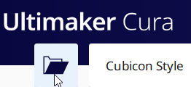

1. **Select the 3d printer**  
   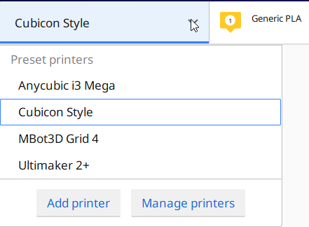
2. **Adjust the model**

Left-click on the model to highlight and use the Adjustment Tools. These tools can be used to position, scale and rotate the object. The following tools are available: Move, Scale, Rotate and Mirror.  
  


1. **Select the material**

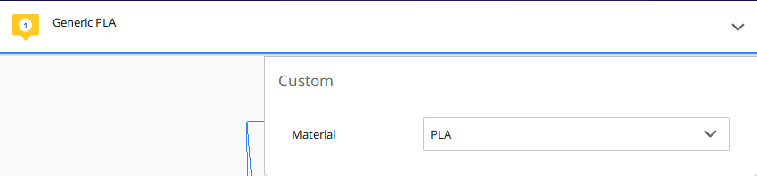

1. **Printer settings** are displayed at the top right-hand corner. Left click on the tool bar.



1. **Choose the profile quality**  
   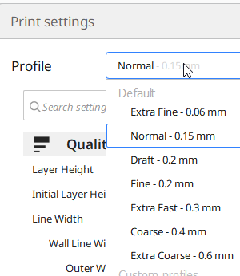
2. **Recommended mode is ideal for normal user**. Click on the Recommended button.  
   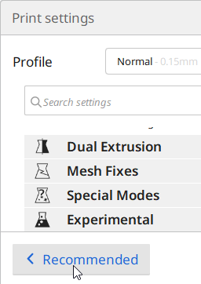  
   It has 3 simple options to complete the Printing Profile:   
   • Infill density, to choose the model strength   
   • Build plate adhesion, to prevent model from moving or becoming loose   
   • Support structure, to print bridges and sharp overhangs  
     
   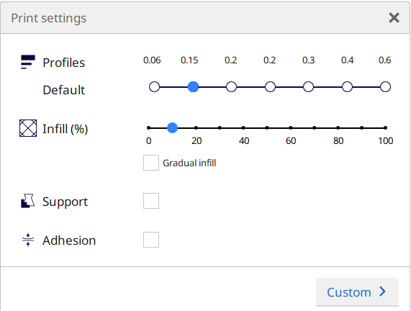
3. **Click on the slice option**  
   
4. **Preview**  
   Click on the preview button to see how each layer is printed.  
   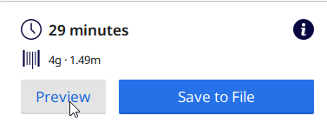  
   Press the play button to see how each layer is printed.  
   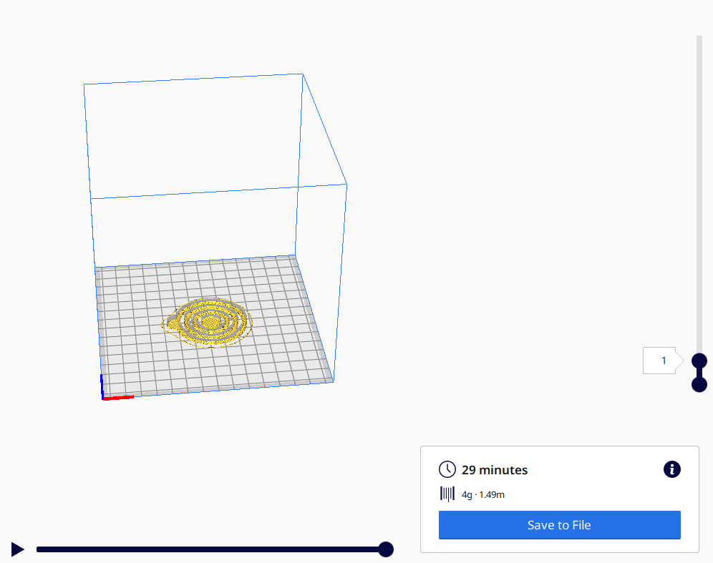
5. **Print**  
   Press the save to File and copy the program to the SD card or USB flash drive.  
   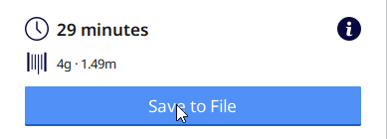

** If you are using Cubicon Style, you need to rename the extension from gcode to hvs after saving it to the SD card.